**Lab Exercise 3- Working Outlook Email (read an Excel file and Send Automated Email)**

**Step 1: Create Excel File**

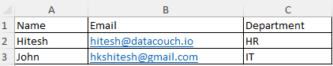

**Step 2: Take Read from Excel Worksheet**

**Step 3: Take For each loop and configure as following**

**Sub-Steps are given below:-**

